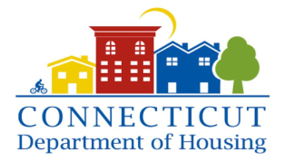
THE HOUSING AND COMMUNITY DEVELOPMENT LEADERSHIP INSTITUTE
Program Application

WHAT PROFESSIONAL
PROGRAM ARE YOU
INTERESTED IN?
(Check all that apply)
- Asset Management
- Affordable Housing Development
- Housing Education & Counseling
- Non-Profit Management & Leadership
- Grant Writing and Tax Credits

*Please provide a resume and a written statement regarding your interest in being part of this exciting program.

If you have any questions, contact Dale Kroop a 203-668-7084 and return this application and Resume and Statement to Dale Kroop at
communityresources@comcast.net

.
Name
Current Occupation _____________________________________________
Home Address
City/State ZIP __________
Home Phone
Personal E-mail
How long have you been in your current position?
Year(s) months

Do you have access to a Computer and Wifi
Yes___ No___ Explain __________________________________

What is the highest level of education you have completed?
❍ High school diploma/GED ❍ Some college ❍ Bachelor’s degree ❍ Other
Please specify any degrees or professional certificates you have earned:
__________________________________________________________
Which sector are you interested in?
❍ Public ❍ Private
❍ Are you affiliated with a non-profit organization or municipality? ❍ Yes ❍ No
If yes, what organization or town are you affiliated with
__ _____

